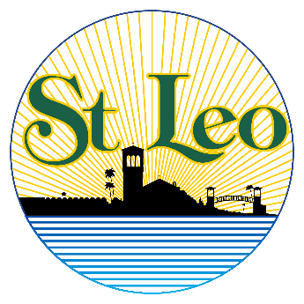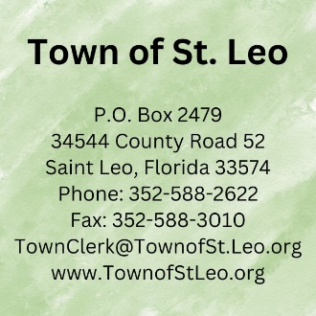

Neighborhood News

10/24/23



**Discovery Fellowship Church Notice and Construction Update**

The First Baptist Church is busy building Discovery Fellowship Church in Town.

For more information about First Baptist, go to https://www.fbcdadecity.org/

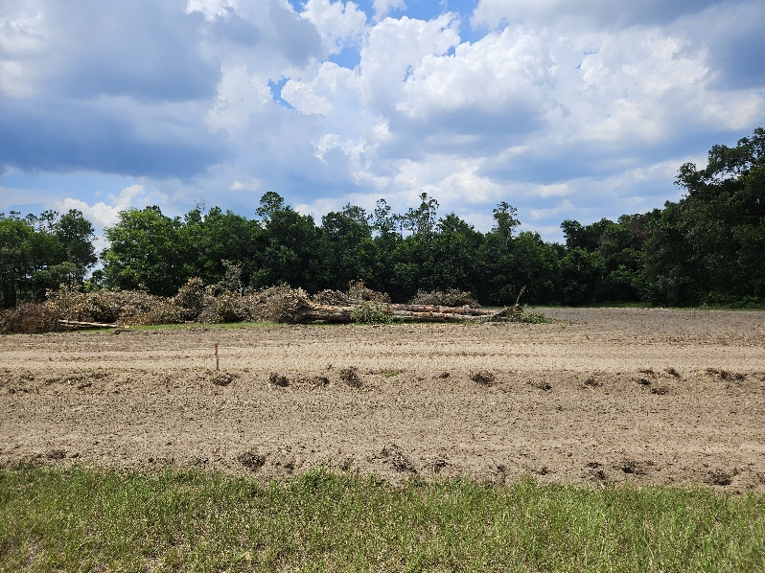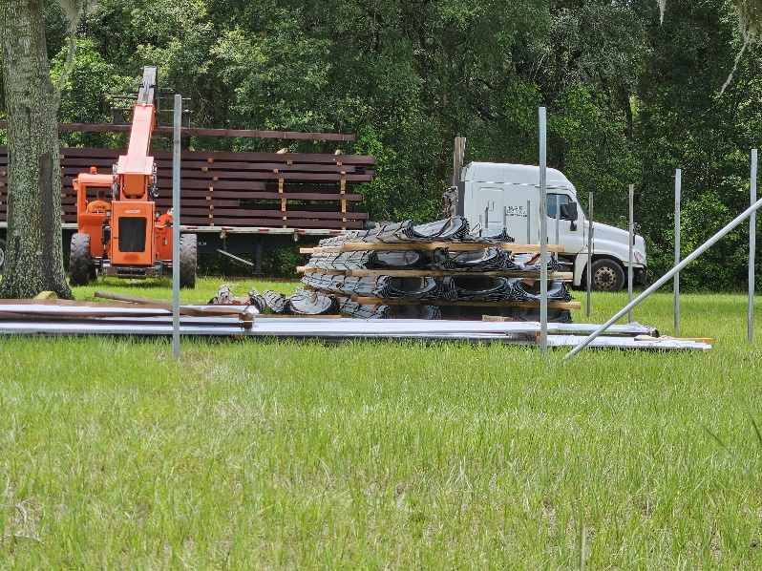



**Zip Code Update**

The Town’s goal is for the St. Leo Zip Code to align with the Town’s municipal boundaries. The Zip Code is currently only assigned to the St. Leo Post Office building. To update it, the United States Postal Service requires us to initiate their Zip Code Boundary Review process. We are working to do that, and will be asking our institutions for letters of support.

l

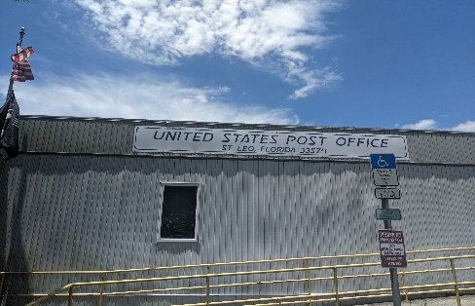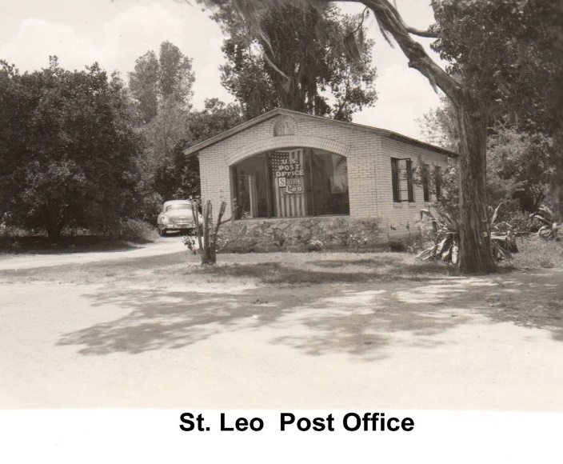





**Lake Watch Update**

At the 11/13/23 Town Commission meeting, Daniel Willis (Regional Coordinator for the University of Florida’s LAKEWATCH program) will be speaking about the health of

Lake Jovita.

**Blood Drive**

On December 8th from 9 AM to 11 AM, the Town will be hosting a blood drive at A Cup of Organic.

To schedule an appointment,

contact Rebecca at Town Hall. [**merwinr@townofstleo.org**](mailto:merwinr@townofstleo.org)or

352-588-2622

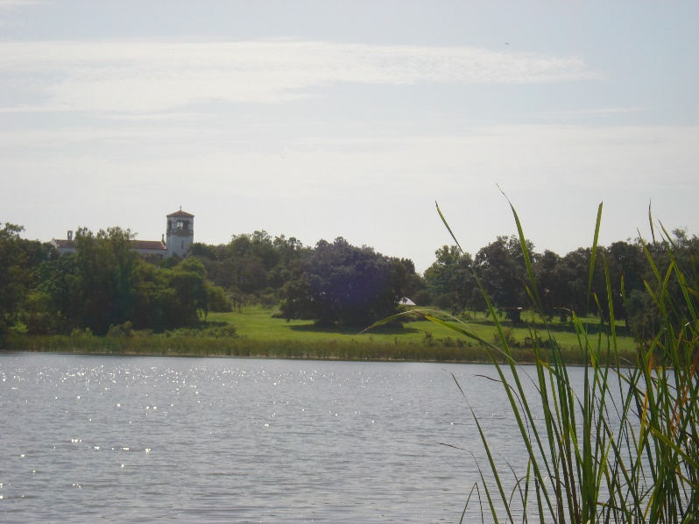

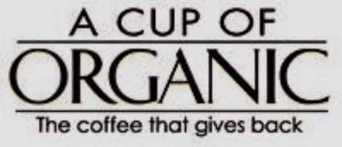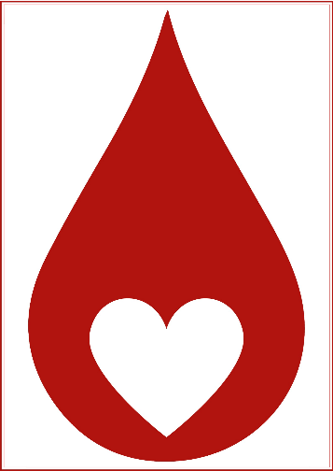





**Saint Leo University Cannon Memorial Library**

Cannon Memorial Library has a Community Patron Program for individuals that live in the surrounding area who want to use the library’s services. To apply go to https://slulibrary.saintleo.edu/library_home, then go to the Forms tab and apply using the Community Patron Program application.

**Pasco County Fire Rescue**

**Knox Boxes**

Pasco County Fire Rescue has a voluntary Knox Box program. Residents can purchase a Knox Box and place it at the front of their house to put a house key in. The box must be registered with Pasco County Fire and Rescue. If there is an emergency, they will be able to use the key to open the resident’s front door. For more information call Pasco County Fire Rescue at 813-929-2750.

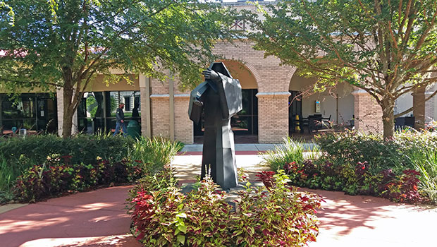

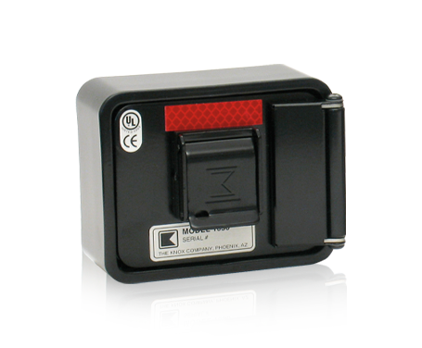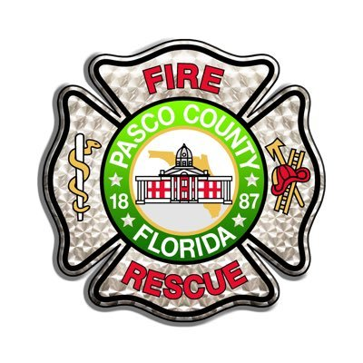



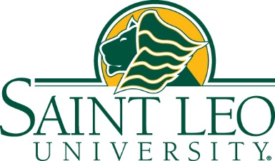

**FOR IMMEDIATE RELEASE:** September 26, 2023

**Pride Pass Available for Public to Attend Saint Leo University Athletics Events**

**ST. LEO, FL** – Tell your neighbors, family, and friends: The Pride Pass has returned! The Saint Leo University Department of Athletics is offering the Pride Pass for 2023-2024 sporting events. The public now may purchase fall, winter, spring, and all-sports Pride Passes.

In addition, Saint Leo University’s Dining Services has reinstated the fan-favorite perk of discounted meals in the Saint Leo Dining Hall as a bonus.

**The Fall Pride Pass** includes all home volleyball and men's and women's soccer games — $65 for general admission and $55 for seniors 62 and older.

**The Winter Pride Pass** includes all home men's and women's basketball games — $ 75 for general admission and $65 for seniors 62 and older.

**The Spring Pride Pass** includes all home baseball, softball, acrobatics & tumbling, and men's and women's lacrosse games — $ 160 for general admission and $130 for seniors 62 and older.

**The All-Sports Pride Pass** includes entrance to the 10 sporting events listed above for the price of $300 for general admission and $250 for seniors 62 and older.

Members of the public who purchase the passes receive a discount on breakfast, brunch, lunch, and dinner meals in the Dining Hall not only on game days, but every day. The cost will be $10. They also may join the Pride Perks Club for a buy-nine-get-one-free at Benedict's Coffeehouse, a We Proudly Serve Starbucks® location and will have access to promotional offers at all Saint Leo retail locations.

Pride Passes may be purchased at <https://saintleolions.com/sports/2021/11/30/tickets.aspx>. Those wishing to make a purchase should scroll down to the appropriate Pride Pass listing.

Any questions about Pride Passes or individual game tickets can be directed to Carrie Fidurko, director of Athletic Operations & Events, at (352) 588-7327 or [athletictickets@saintleo.edu](mailto:athletictickets@saintleo.edu).

For more information on the dining perks, call (352) 588-8421 or visit <https://www.saintleo.edu/student-experience/on-campus/dining> for hours of operation. Only credit cards are accepted at Dining Services locations.

**About Saint Leo University**

Saint Leo University is a Catholic Benedictine university dedicated to helping learners of all backgrounds and ages gain the competence and courage to be more. Offering 57 degree programs to more than 14,190 students each year, the nonprofit university is known for providing a values-based education in the liberal arts tradition and a community of belonging for those who seek a greater purpose in life. Saint Leo is regionally accredited and offers a campus in the Tampa Bay area of Florida, regional education centers, and multiple online programs. The university is home to more than 104,000 alumni. Learn more at [saintleo.edu](https://www.saintleo.edu/).

**Media Contact:** Mary McCoy, Senior Editor & Media Relations Manager, [mary.mccoy02@saintleo.edu](mailto:mary.mccoy02@saintleo.edu), (352) 588-7118 or cell (813) 610-8416





**FOR IMMEDIATE RELEASE:** October 12, 2023

**Saint Leo U Hosting ‘Living Legend: Reflections from a 101-year-old Veteran’ on October 26, Welcoming World War II Buffalo Soldier**

**ST. LEO, FL –** The public is invited to discover “living history” during Saint Leo University’s upcoming Research Symposium featuring legendary 101-year-old U.S. Army veteran Roy Caldwood on Thursday, October 26.

Guest speaker Caldwood will share his journey of resilience and valor during World War II and later as a corrections officer at Rikers Island. The event will take place 11 a.m., Thursday, October 26, at the Student Community Center, Greenfelder-Denlinger Boardrooms, 33701 County Road 52, St. Leo, FL 33574. Those who cannot attend in person may attend via Zoom at [www.saintleo.edu/caldwood](http://www.saintleo.edu/caldwood). RSVPs are required to attend via Zoom and participants are asked to email [karen.hannel@saintleo.edu](mailto:karen.hannel@saintleo.edu).

This event is sponsored by the university’s Department of Social Sciences, the College of Arts, Sciences, and Allied Service, Office of Military Affairs and Services, the Caribbean Students’ Association, and Alpha Kappa Delta International Sociology Honor Society.

Caldwood served in Italy during World War II as part of the renowned Buffalo Soldiers, the 92nd Infantry Division of the U.S. Army, named after the 19th century African American cavalrymen. He holds the esteemed title of being the last known Buffalo Soldier in the state of Florida, recognized by the National Buffalo Soldier organization.

As a U.S. Army Bronze Star recipient and the author of the memoir *Making the Right Moves: Rikers Island & NYC Corrections*, his story resonates with courage and resilience, stated the organizers of the event. Earlier this year, Tampa Mayor Jane Castor proclaimed April 5, 2023, as Roy Caldwood Day. He also received the New York City Department of Corrections Medal of Honor.

Signed copies of *Making the Right Moves: Rikers Island & NYC Corrections* will be available for sale at the event at Saint Leo University.

Requests for accommodations can be made by emailing [Section504@saintleo.edu](mailto:Section504@saintleo.edu). For more information, visit [saintleo.edu/accommodations](https://www.saintleo.edu/about/title-ix#toc-requesting-accommodations).

For more information, contact Dr. Janis Prince, chair of the Department of Social Sciences, at (352) 588-7254 or [janis.prince@saintleo.edu](mailto:janis.prince@saintleo.edu).

Funding for this symposium was made possible in part by a Sociological Research Grant from Alpha Kappa Delta International Sociology Honor Society. The views expressed in written symposium materials and by speakers and presenters do not necessarily reflect the official opinions of Alpha Kappa Delta; nor does mention of trade names, commercial practices, or organizations imply endorsement by Alpha Kappa Delta.

**About Saint Leo University**

Saint Leo University is a Catholic Benedictine university dedicated to helping learners of all backgrounds and ages gain the competence and courage to be more. Offering 57 degree programs to more than 14,190 students each year, the nonprofit university is known for providing a values-based education in the liberal arts tradition and a community of belonging for those who seek a greater purpose in life. Saint Leo is regionally accredited and offers a campus in the Tampa Bay area of Florida, regional education centers, and multiple online programs. The university is home to more than 104,000 alumni. Learn more at [saintleo.edu](https://www.saintleo.edu/).

**Media Contact:** Mary McCoy, Senior Editor & Media Relations Manager, [mary.mccoy02@saintleo.edu](mailto:mary.mccoy02@saintleo.edu), (352) 588-7118 or cell (813) 610-8416



**Saint Leo University’s Dining Services announces hours for Veterans Day, Thanksgiving Break**

**Saint Leo University’s Dining Services is announcing its hours of operation for Veterans Day and Thanksgiving Week.**

For additional information regarding Dining Services hours of operation, please contact Justin Bush, director of Dining Services, at [justin.bush@saintleo.edu](mailto:justin.bush@saintleo.edu).

**Friday, November 10 –** **Veterans Day**  
The Dining Hall will be open for continental breakfast 9:30-10:30 a.m.; brunch from 11 a.m. to 1 p.m.; and dinner 4:30-6 p.m.   
FUZ, Saint Leo Fusion Eatery and Benedict's Coffeehouse will be closed.

**Monday, November 20, and Tuesday, November 21**  
The Dining Hall will be open for breakfast 8-9 a.m., lunch from 11 a.m. to 1 p.m., and dinner 4-6 p.m.  
FUZ and Benedict's Coffeehouse will be closed.

**Wednesday, November 22**  
The Dining Hall will be open 7:30–9 a.m. and from 11 a.m. to 1 p.m. A to-go container will be provided for a takeout dinner option.  
FUZ and Benedict's Coffeehouse will be closed.

**Thursday, November 23 – Thanksgiving Day**  
*All dining locations****closed***.

**Friday, November 24**  
*All dining locations****closed***.

**Saturday, November 25**  
The Dining Hall will be open for brunch from 11 a.m. to 1 p.m. and for dinner 4-6 p.m.  
FUZ and Benedict's Coffeehouse will be closed.

**Sunday, November 26**  
The Dining Hall will be open for brunch from 11 a.m. to 1 p.m. and for dinner 4-6 p.m.  
FUZ and Benedict's Coffeehouse will be closed.

**Monday, November 27**  
All dining locations resume normal hours.

**FOR MORE INFORMATION:**  
Please visit [Dining Services | Saint Leo University](https://www.saintleo.edu/student-experience/on-campus/dining) for regular hours of operation for the Dining Hall, FUZ Saint Leo Fusion Eatery, and Benedict’s Coffeehouse.



**Town Hall Team**

Rebecca Merwin – Assistant Town Clerk

Gabriel Quinn – Intern

Luke D’Ambrosio – Intern

Andrea Calvert – Town Clerk

Maintenance Position – Open. See Town website or contact Clerk’s Office for more details.



**Battery Recycling**

Any kind accepted; drop them off at Town Hall.



NEXT MEETING:

**Commission Meeting 7:00 PM 11/13/23**

